Active Grid Quick Start Guide

1. Connect each column of the active grid to power. There is one 5V power supply and one 12V power supply for each column. They are labeled and on extension cords with individual switches (or individual extension cords) for convenience in controlling them separately.

GND – Black

5V – Red

12V – any other color (brown or yellow or teal)

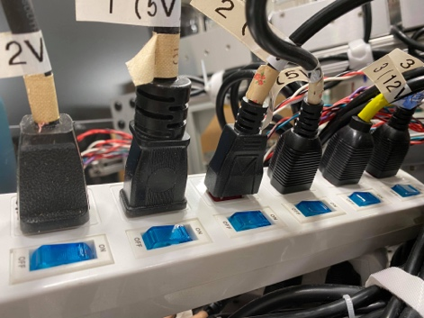 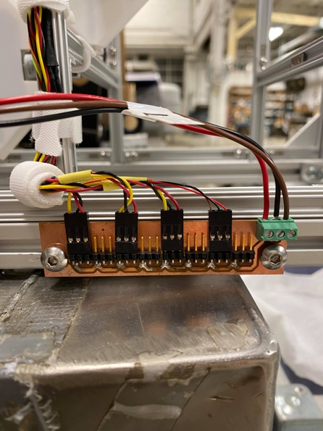

(on screw terminal: 5V, GND, 12V

from left to right)

1. Turn on router (will not connect to internet)

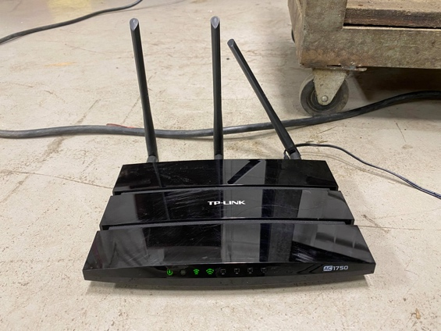

1. On laptop or computer where you will be running the matlab code:

go on TP-LINK_6BCD (pw: 51360306)

1. Run active_grid.m as needed (on <https://github.com/d008/ActiveGrid>)

‘H’ is the homing protocol

‘R1D400S360T1’ means

Numbering convention:

column

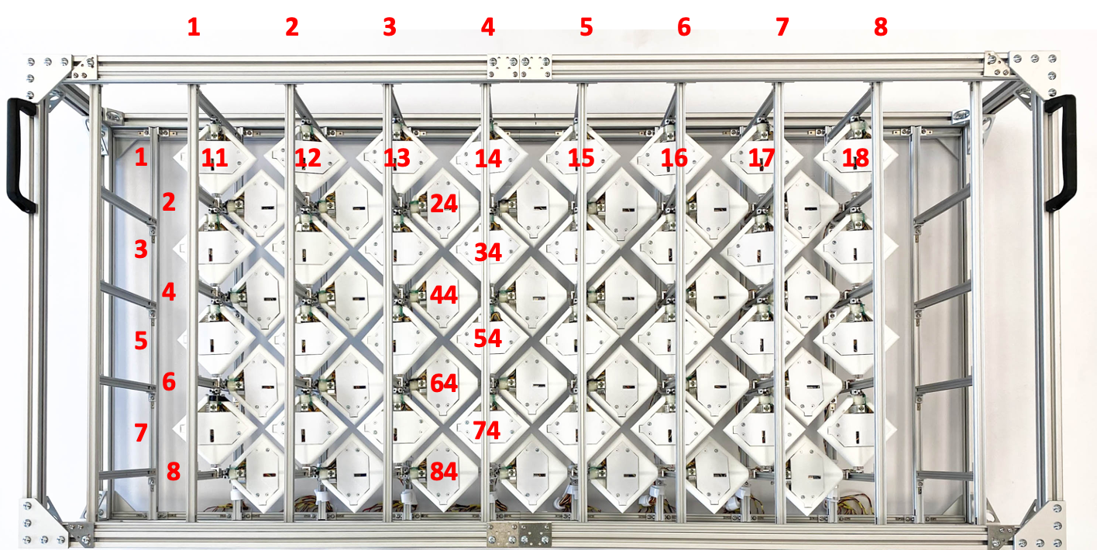

row

Troubleshooting:

1. Turn power on and off and restart
2. Restart Matlab
3. Check that the IP address assigned to the winglets are not used for anything by the system.

Word of caution:

I have not tested how long each motor can run for, but in the previous iteration, the stepper motors overheated and melted its own plastic casing so that it is no longer usable. The current limit on the stepper motor driver should prevent this from happening, but should be careful if running continuously with no pause in between. Lastly, the small heat sinks on the motor itself are also in place to prevent overheating – perhaps another method that is more suited for curved surfaces could be explored.

Uploading code to ESP8266

1. The way it is set up is that each winglet has its own IP address through which Matlab communicates and sends instructions.
2. [Arduino IDE]
   1. Connect ESP8266 to computer and open main.ino (also at <https://github.com/d008/ActiveGrid>)
   2. Make sure Tools 🡪 Board: ESP8266 Boards 🡪 “WeMos D1 R1”
   3. Check that the ip address you are uploading matches the winglet #

For example, for winglet #83, the IP address will be (192,168,0,183)

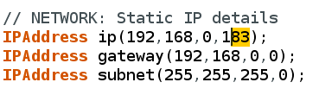

* 1. Upload!